

**UNIVERSITI TEKNOLOGI MALAYSIA, JOHOR BAHRU**

**SEMESTER I - 2019/2020**

**SCSJ 2013 – DATA STRUCTURE AND ALGORITHM**



Queue Management System for Campus Election in University of Technology, Malaysia



**GROUP NAME :** Evil Geniuses

**LECTURER’ NAME :** Dr. Ruhaidah binti Samsudin

**GROUP MEMBERS :**

|  |  |  |
| --- | --- | --- |
| 1) | AZMIL AZIZI BIN NORDIN | A18CS0041 |
| 2) | AINAL FARHAN |  |
| 3) | ALONG |  |
| 4) | FAIZ HAKIMI |  |

## Objective of the mini Project.

This project plans to execute campus elections in university with more manageable and time-savvy way. The mini Project that we are proposing are mainly based on the listed objectives below:

* + Ensuring orderly flow of voters in taking turns for voting process.
  + Making sure that queuing does left students unoccupied.
  + Decrease area crowd.

## Synopsis of the mini Project.

* + Project Title :

Queue Management System for Campus Election in University of Technology, Malaysia.

* Domain :

Data Structure and Algorithm – Queue

* Problem statement :

Taking turns for voting are usually cause time inefficiency and crowded environment.

* Project description :

The system to be developed is on Queue Management. In this system, we are implementing queue using linked lists. There will be 2 users of the system, the election officer and the voter. The election officers should be able to facilitate the queueing process while have full knowledge of the system control. In the other hand, the voters should be able to key in details in the Queue Management System.

When the voter first arrives for voting, the election officers will brief the procedures of queuing using the proposed system. Voters will then be instructed to key in details. The voter’s details will be used for turn taking, and data recording. If the queue is full, the voters will be able to key in their details in advance and when their turn is up, they will be notified to show up.

## Flowchart

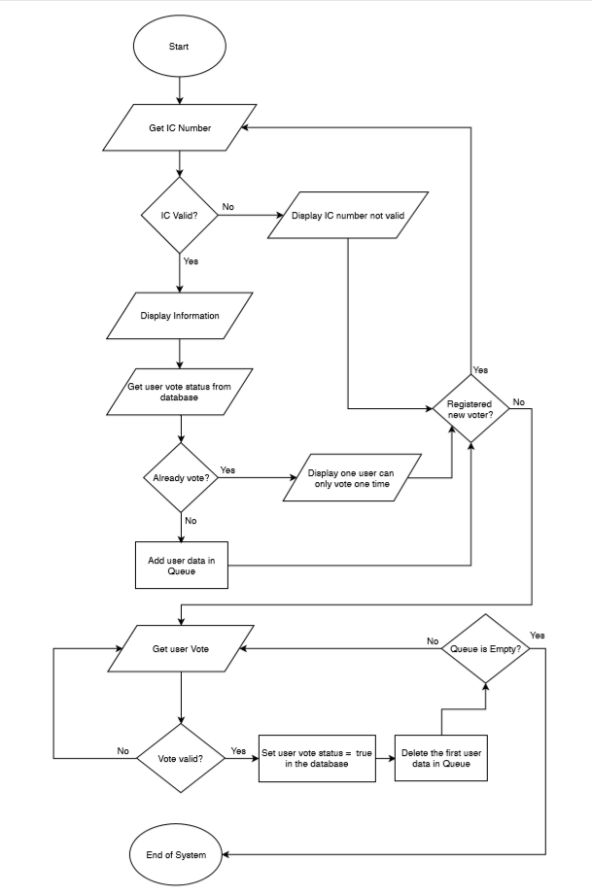

## Case Diagram

## 